**This New Discovery Could Put Quantum Computers within Closer Reach**

Jaehyung Park

University of California, Los Angeles

COM SCI 35L

Lab 1

**Abstract:**

Quantum computers are introduced to revolutionize the computing history due to the superior processing power. Although the technological advancement in quantum computer seems to be the bright future in the field of computer engineering, there are technical drawbacks that need to be conquered, such as the main processing chip needs to be cooled close to absolute zero temperature to get quantum effects and be shielded to take less Earth’s magnetic field for its stable performance. The article on Computer World [1] shows how a group of researchers found to solve issues with the effects on electromagnetic field. This review focuses on the background of quantum computers, discovery of the research and possible applications [3].

**Introduction:**

Nowadays, computers are used in many form factors from big tower servers, workstations, home personal computers, smartphones, tablets, IOT devices, and even a card size compact computers and more. One thing in common is that most of these computers use a processor, rather it is CISC or RISC that follows the Von Neumann Architecture as its main processing architecture. Quantum computers on the other hand uses a non-traditional architecture to do its computation [4]. With the use of qubits, quantum computers have faster processing capabilities compared to conventional computers that can be used in encryption and NP-complete solving. But, quantum computers require two factors to be solved and one of them is to block the effects of electromagnetic fields to the quantum processing chip. A discovery on atomic clock transition was made from Florida State University’s Magnetic Field Laboratory (MagLab) to drastically reduce the Earth’s magnetic field on quantum computer processors by utilizing the concept of noise canceling headphones [1].

**Background of quantum computers:**

Compared to the traditional Von Neumann Architecture based computers, quantum computers use Shor’s algorithm as their primary quantum algorithm to compute complex calculations [4]. Modern computers that use classical bits which are ones and zeros, but quantum computers use quantum bits, or other known as qubits to do its computation [4]. Qubits can be both zeros and ones at the same time, which makes quantum computers to show superior performance over modern computers. More specifically, a modern computer can process only 2 bits of information which are 0 and 1. A quantum computer, however, can process the superposition of 2 qubits to four states which are 00, 01, 10, 11 [4]. This allows qubits to contain four bits of information which implies that N qubits are equivalent as 2N classical bits [4].

**Description of the topic:**

The article from Computer World shows the discovery of the atomic clock transition that was made from Florida State University’s MagLab team [1]. Katherine Noyes from Computerworld mentioned “with carefully designed tungsten oxide molecules that contained a single magnetic holmium ion, the MagLab team was able to keep a holminum qubit working coherently for 8.4 microseconds” which makes it long enough to perform useful computational tasks [1]. The MagLab team was able to discover electron spin qubits based on clock transitions to mitigate the effect of local magnetic environment or electric field noise by bonding bismuth donors into silicon [2].

**Results of the discovery:**

The research is based on a powerful method that is applied to trapped ions in the context of frequency standards and atomic clocks. The concept of clock transition came from a transition frequency that is immune to magnetic field variations [2]. This method uses ion trapped qubits that are immune to magnetic fluctuations and works on hyperfine state atomic clocks to inherent robust external perturbations from particular spin transitions [2]. In other words, the electron spin qubits based on clock transitions mitigate the effects of magnetic or electric field noise arising from nearby interfaces [2]. Since quantum computing processors are confined in a shielded container, the purpose is to reduce the effects of Earth’s magnetic or electric field that can bottleneck the performance and stability.

Figure 1 shows that clock transitions in Si:Bi (Silicon:Bismuth bond) can be used to produce magnetic field-insensitive spin qubits with directly measured coherence times of several seconds [2]. These qubits would be insensitive to magnetic field noise arising, which clock transitions can be designed to be immune from electric charge noise. Eventually, atomic clock transitions will allow quantum computing processors to be immune from the effects of electric fields [2].

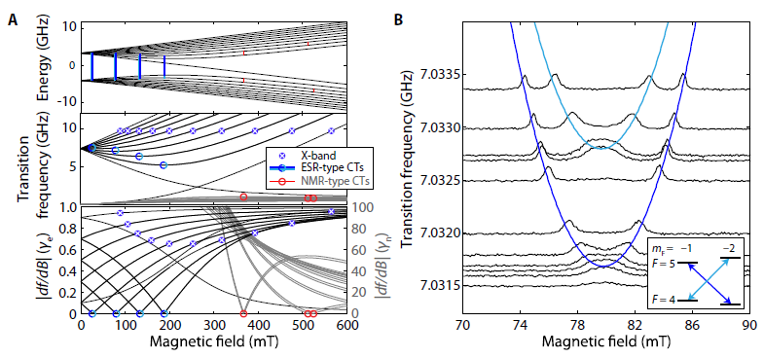

**Figure 1. Electron spin resonance (ESR)-type clock transitions (CTs) of Si:Bi.** The top graph of A is the eigenstate energies of Si:Bi as a function of the magnetic field, the middle graph is the NMR-type transition frequencies between the given states, and the bottom graph is the first-order magnetic field dependence (df/dB) [2]. Graph B shows the electron spin echo-detected magnetic field around the 80mT clock transition that is measured at microwave frequencies above 7.0315 Ghz [2].

Diagram A in figure 2 shows the central spin representation of the surrounding Bi and Si spins that are separated into three different categories. The first is the resonant Bi spins that are affected by microwave excitation that is represented in blue color, the second is the off-resonant spins by Bi spin microwaves that is represented in light blue color, and the third is other Si spins in red color [2].

The central Bi spin and the neighboring resonant Bi spin contains a spectral diffusion and the direct flip-flop (dFF) and counteracts with the off-resonant Bi spin with spectral diffusion [2]. This behavior leaves only the direct flip-flop (dFF) between the central spin and the neighboring resonant Bi spin [2].

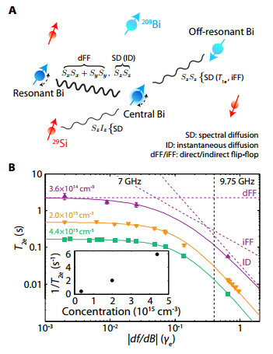

**Figure 2. Decoherence mechanisms of Bi donors in silicon and their dependence on df/dB.** Graph A is the central spin representation that a Bi donor is coupled to a neighbored Bi donor [2]. Graph B shows the measurements of 3 different donor concentrations in the Si:Bi relationship at 4.8K temperature [2].

The use of clock transitions in Silicon and Bismuth bond produces magnetic field insensitive spin qubits that can last for a couple of seconds [2]. Graph B in figure 2 shows the measured values of electron spin coherence times at X-bands [2]. The clock transition taken at 4.8K temperature has T1e = 9s but does not increase in T2e even at lower temperature, which the duration of time does not change that much by decreasing the temperature [2].

**Conclusions and Reviews:**

The result shows that Florida State University MagLab team’s discovery is able to drastically reduce the effect of Earth’s magnetic field by implementing the idea how noise canceling headphones work [1]. Since the atomic clock transition method is still in progress, researchers are expecting to see some tangible improvements of quantum computing over the next decade to be widely used in real life applications. There are factions in parallel computing to increase performance and use this performance in military infrastructures. Lockheed Martin bought a D-Wave quantum computer couple of years ago for classified uses [6]. Other applications are artificial intelligence, especially in machine learning and optimization to solve problems. Also, quantum computers will be in great demand for encryption and code breaking in government agencies such as the NSA and university research labs. Google is planning to improve web search and NASA is making robots to send outer space to hunt for exo-planets and optimize air-traffic controls [5].

**References:**

[1] K. Noyes, “This new discovery could put quantum computers within closer reach” Computer World, 2016. [http://www.computerworld.com/article/3045046/high-performance-computing/this-new-discovery-could-put-quantum-computers-within-closer-reach.html]

[2] G. Wolfowicz, et al., “Atomic clock transitions in silicon-based spin qubits” Nature technology, 2013, Vol 8. pp. 561-564

[3] M. Shiddiq, et al., “Enhancing coherence in molecular spin qubits via atomic clock transitions”, Nature, 2016, Issue. 531, pp.348-351

[4] A. Hagar, and M. Cuffaro, “Quantum Computing”, The Stanford Encyclopedia of Philosophy, 2015.

[http://plato.stanford.edu/archives/sum2015/entries/qt-quantcomp/]

[5] S. Weinberger, “Why Google and the Pentagon want ‘quantum computers’”, BBC, 2014. [http://www.bbc.com/future/story/20130516-big-bets-on-quantum-computers]

[6] M. Ravindranath, “Lockheed Martin’s bet on quantum computing”, The Washington Post, 2014. [https://www.washingtonpost.com/business/on-it/lockheed-martins-bet-on-quantum-computing/2014/03/15/9db067f8-a61b-11e3-84d4-e59b1709222c_story.html]